WEEK 3 PROJECT REPORT
Python-Based Machine Learning Model Development and Evaluation Plan
Student Performance Prediction Using Python and Machine Learning
Report Detail | Information
Student | Varun Kumar
Project | Student Performance Prediction Using Python and Machine Learning
Week | Week 3
Deliverable | Machine Learning Model Development and Evaluation Plan
Planned Effort | 32 hours
Implementation Status | Planning stage; no actual execution required

All numerical values used as examples are illustrative planning values, not experimental results.

1. Executive Summary
This report provides a detailed plan for developing, training, validating, evaluating and eventually deploying a machine learning model for the Student Performance Prediction project. The proposed system will use academic, attendance, engagement and related features to predict an At Risk/Not At Risk outcome, while regression remains an alternative if the final target is a continuous score.
The plan connects Week 2 EDA to modeling through reproducible preprocessing, detailed multivariate analysis, feature engineering, leakage prevention, baseline and ensemble models, hyperparameter tuning, cross-validation, final testing, error analysis, documentation and future maintenance.

2. Direct Response to Week 2 Feedback
Feedback | Improvement in Week 3
Complete the multivariate analysis section | The report explains correlation structure, grouped multivariate comparisons, interactions, multicollinearity, feature selection and error-segment analysis, then connects these findings to modeling decisions.
Add specific tools and templates for documentation | The plan includes Jupyter, pandas, scikit-learn, Git/GitHub, README, Data Dictionary, Experiment Log, Model Card and Risk/Issue Log templates.
Strengthen reporting plan | Every experiment records dataset version, features, preprocessing, model, hyperparameters, CV results, test results, errors and next decision.

3. Problem Definition

3.1 Hypothetical Problem
Predict whether a student is likely to be At Risk or Not At Risk using information available before the final outcome is known. Candidate inputs include attendance percentage, internal assessment average, previous performance, assignment completion, study time and participation.

3.2 Relevance
- Early identification: helps identify patterns associated with academic risk.
- Multiple factors: performance is influenced by variables acting together.
- Scalability: a validated model can process new records consistently.
- Decision support: predictions can support mentoring and academic follow-up, rather than replace human judgment.

3.3 Target Options
Target | Example | Candidate Models
Classification | At Risk=1, Not At Risk=0 | Logistic Regression, Decision Tree, Random Forest, Gradient Boosting
Regression | Final score as a continuous value | Linear Regression, Random Forest Regressor, Gradient Boosting Regressor

4. End-to-End Workflow
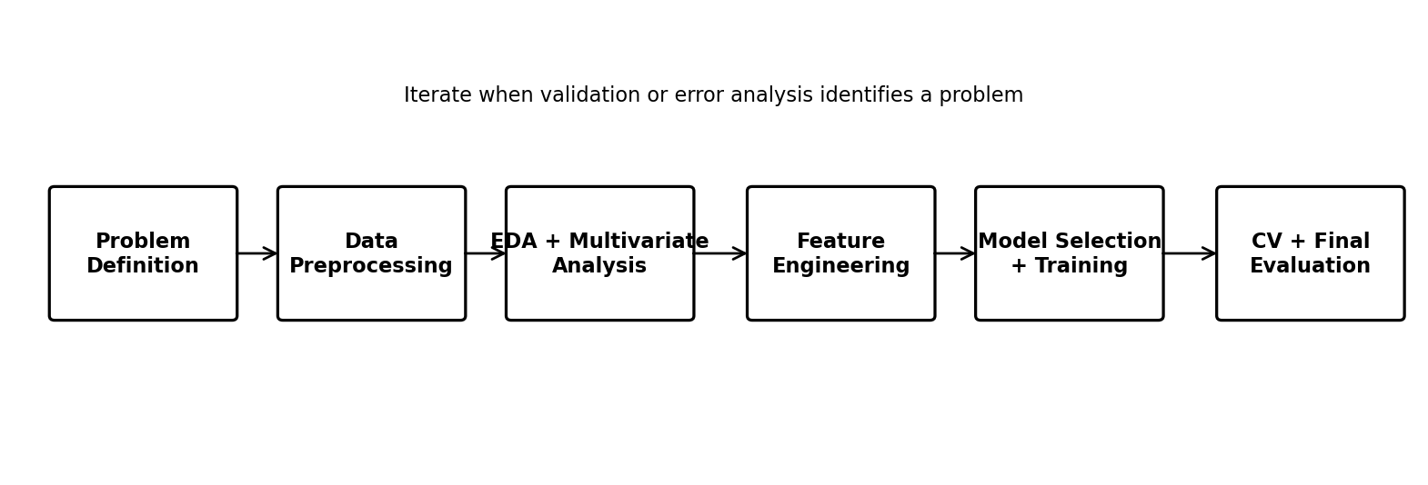
Figure 1. Planned machine learning workflow.

5. Data Preprocessing

5.1 Data Inspection
- Load and inspect: shape, columns, data types, sample rows and summary statistics.
- Missing values: count and percentage for each feature; investigate patterns.
- Duplicates: identify repeated records and determine whether they are valid.
- Range checks: verify domain limits such as marks and attendance.
- Target checks: verify valid labels and sufficient representation.
Illustrative Python checks:
df.shape\ndf.info()\ndf.isna().sum()\ndf.describe(include="all")

5.2 Cleaning and Missing Values
Situation | Planned Treatment | Reason
Low missing numeric values | Median imputation inside pipeline | Robust to extreme values
Categorical missing values | Most-frequent or Unknown category | Retains records
High missingness | Investigate; possibly remove feature | Avoid unstable information
Missing target | Exclude after investigation | Supervised learning needs labels

5.3 Outliers
Investigate IQR rules, box plots and domain constraints. Rare values will not automatically be deleted. Treatment may be retain, cap, transform or remove, with the reason documented.

5.4 Encoding and Scaling
- Categorical: One-Hot Encoding for nominal variables; ordinal encoding only when order is meaningful.
- Numerical: StandardScaler for scale-sensitive models.
- Tree models: scaling is generally unnecessary.
- Pipeline: fit preprocessing only within training folds to prevent leakage.

5.5 Feature Engineering
Feature | Example Construction | Purpose
Assessment average | (Internal 1 + Internal 2)/2 | Summarize repeated assessments
Assignment rate | Completed / Total | Measure engagement
Performance trend | Recent score − previous score | Capture improvement/decline
Attendance band | Meaningful attendance groups | Capture nonlinear patterns
Interaction | Attendance × assessment average | Capture combined effect
Participation indicator | Above a justified threshold | Represent engagement

6. Detailed Multivariate Analysis-to-Modeling Plan
This section directly extends the Week 2 feedback. Multivariate analysis will go beyond a single heatmap and will be used to decide which features, transformations and model families deserve further testing.
Technique | Example | How It Guides Modeling
Correlation structure | Attendance, assessment average, previous score | Detect redundant numeric variables.
Grouped multivariate comparison | Several features compared jointly by risk group | Identify combinations associated with the target.
Pairwise relationship plots | Attendance vs score, colored by risk | Detect clusters and nonlinear patterns.
Multicollinearity review | Correlation/VIF review | Reduce redundant predictors where justified.
Interaction analysis | Attendance × assessment average | Test whether combined effects improve validation results.
Dimensionality review | Multiple related assessment columns | Consider consolidation or feature selection.
Error-segment analysis | False negatives by attendance band | Identify subgroups needing improvement.

Example reasoning: if attendance and previous marks are individually useful and their combination creates clearer separation, an interaction feature or tree-based model can be tested. The feature will be retained only if cross-validation supports it. This prevents adding complexity without evidence.

7. Model Selection and Training
Model | Purpose | Strength | Limitation
Logistic Regression | Baseline | Interpretable, fast | Limited nonlinear behavior
Decision Tree | Nonlinear baseline | Captures interactions; easy to explain | Can overfit
Random Forest | Primary ensemble candidate | Robust nonlinear relationships | Less directly interpretable
Gradient Boosting | Advanced comparison | Can model complex patterns | Requires careful tuning

7.1 Training Sequence
- Split data: use a stratified train/test split for classification.
- Build pipeline: imputation, encoding, scaling and feature steps inside a reproducible pipeline.
- Train baseline: establish an interpretable reference.
- Compare candidates: use the same validation protocol.
- Tune: GridSearchCV or RandomizedSearchCV only within training data.
- Select: consider mean CV performance, stability, interpretability and error patterns.
- Final test: evaluate once on the untouched test set.

7.2 Hyperparameter Plan
Model | Examples
Decision Tree | max_depth, min_samples_split, min_samples_leaf
Random Forest | n_estimators, max_depth, min_samples_split, max_features
Gradient Boosting | n_estimators, learning_rate, max_depth, subsample
Logistic Regression | C, penalty, solver

8. Evaluation Metrics and Validation
Metric | Meaning | Importance
Accuracy | Correct / total | Useful when classes are balanced, but insufficient alone.
Precision | TP/(TP+FP) | Shows how many predicted at-risk cases are truly at risk.
Recall | TP/(TP+FN) | Shows how many actual at-risk cases are detected.
F1-score | Harmonic mean of precision and recall | Balances the two.
ROC AUC | Threshold-independent discrimination measure | Useful for probability-based comparison.
Confusion Matrix | TP, TN, FP, FN counts | Makes error types visible.

For an early-risk identification use case, recall and F1-score will receive particular attention because missed at-risk students can be important. Accuracy will still be reported but will not be treated as sufficient evidence.

8.1 Cross-Validation Strategy
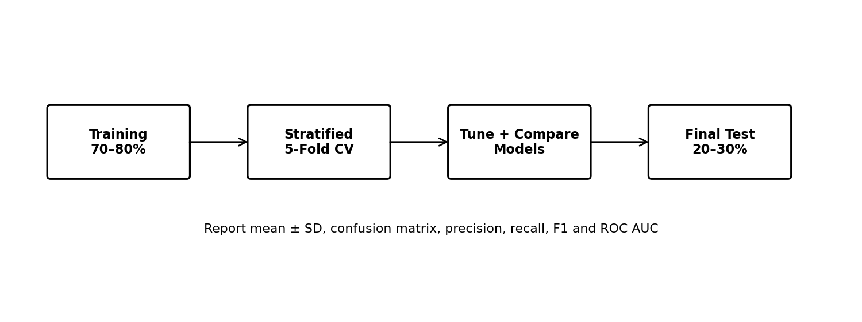
Figure 2. Planned validation and final evaluation strategy.
A stratified 5-fold cross-validation strategy is planned for classification, subject to dataset size. Mean and standard deviation will be reported to show both average performance and stability. The final test set remains untouched until model selection and tuning are complete.

8.2 Regression Alternative
Metric | Purpose
MAE | Average absolute error in score units
MSE | Penalizes larger errors more
RMSE | Same units as target; emphasizes large errors
R² | Explained variance

8.3 Illustrative Result Format
Metric | Illustrative Value
Accuracy | 0.86
Precision | 0.80
Recall | 0.88
F1-score | 0.84
ROC AUC | 0.90

These values are illustrative examples of reporting format only, not actual experimental results.

9. Data Leakage and Reproducibility
- Isolation: keep the final test set untouched.
- Pipeline preprocessing: fit transformations inside training/CV.
- Target leakage prevention: exclude variables that reveal the final outcome or post-outcome information.
- Prediction-time rule: use only information available at the intended prediction moment.
- Random state: document seeds for reproducible comparisons.
- Version control: store code, reports and experiment history in Git/GitHub.

10. Tools and Documentation Templates
Tool / Template | Purpose | Content
Jupyter Notebook | Analysis/model development | EDA, experiments, plots
pandas / NumPy | Data processing | Cleaning and feature calculations
scikit-learn | ML implementation | Pipelines, CV, tuning, metrics
Matplotlib / Seaborn | Visualization | Distributions, confusion matrix, errors
Git / GitHub | Version control | Code, reports, README
README.md | Project documentation | Objective, workflow, setup, results, limitations
Data Dictionary | Feature documentation | Type, definition, range, source, leakage status
Experiment Log | Track model runs | Run ID, model, features, hyperparameters, CV/test metrics
Model Card | Transparency | Purpose, data, metrics, limitations, risks
Risk / Issue Log | Project control | Issue, impact, mitigation, status

10.1 Experiment Log Template
Field | Example
Experiment ID | EXP-003
Dataset Version | v1.0
Target | At Risk / Not At Risk
Features | Attendance, internal average, previous score, assignment rate
Preprocessing | Median imputation + one-hot + scaling
Model | Random Forest
Hyperparameters | Exact selected values
CV | Stratified 5-fold
Results | Mean ± SD
Test Result | Final only
Error Findings | False positives/negatives and segments
Decision | Keep / tune / reject

10.2 Data Dictionary Template
Field | What to Record
Feature name | Exact column name
Data type | Numeric/categorical/date/Boolean
Definition | Meaning of variable
Unit / Range | Percentage, marks, count, etc.
Missing rule | Treatment
Source | Origin
Prediction-time availability | Yes/No
Leakage risk | Low/Medium/High + explanation

10.3 Model Card Template
- Purpose: Predict student performance risk for support prioritization.
- Intended use: Decision support with human review.
- Input data: Document approved prediction-time features.
- Evaluation: Report CV and final test metrics.
- Limitations: Dataset size, representativeness, imbalance and drift.
- Monitoring: Track performance and feature distribution changes.

11. Conceptual Deployment and Maintenance
- Save full pipeline: store preprocessing and model together.
- API: future Flask/FastAPI endpoint can accept validated student data.
- Input validation: reject impossible ranges and missing required values.
- Monitoring: track drift, missingness and class distributions.
- Performance update: recalculate metrics when actual outcomes arrive.
- Retraining: retrain only after data-quality and validation checks.
- Versioning: record model, dataset and training versions.
The model should be treated as decision support rather than an automatic final judgment about a student.

12. Challenges and Solutions
Challenge | Effect | Solution
Class imbalance | Accuracy can mislead | Stratification, class weights, recall/F1, threshold analysis
Small dataset | Unstable estimates | Cross-validation and simpler models
Missing data | Bias or information loss | Pipeline imputation and missingness analysis
Outliers | Distorted behavior | Domain-informed investigation
Leakage | Unrealistically high scores | Strict feature-availability checks
Overfitting | Poor generalization | CV, regularization, depth constraints and tuning
Feature redundancy | Unstable/complex model | Correlation and multicollinearity review
Concept drift | Performance declines | Monitoring and controlled retraining
Interpretability | Reduced stakeholder trust | Baseline model, feature importance and model card

13. 32-Hour Work Plan
Activity | Hours | Output
Problem and target design | 3 | Problem statement and assumptions
Preprocessing strategy | 5 | Cleaning, missingness, outlier, encoding and scaling plan
Multivariate + feature engineering | 4 | Interaction, redundancy and selection plan
Model selection | 4 | Candidate comparison and selection logic
Training + hyperparameter tuning | 4 | Training and tuning strategy
Evaluation + cross-validation | 4 | Metrics and validation protocol
Documentation + reproducibility | 3 | Experiment log, data dictionary, model card, README
Deployment + maintenance | 2 | API and monitoring concept
Diagrams, review and formatting | 3 | Final polished report

Total planned effort: 32 hours.

14. Expected Deliverables
- Detailed Word report
- Machine learning workflow diagram
- Validation/evaluation diagram
- Preprocessing and feature-engineering plan
- Candidate model comparison
- Metrics and cross-validation strategy
- Experiment Log, Data Dictionary and Model Card templates
- Deployment and maintenance concept
- 32-hour work plan

15. Pre-Implementation Quality Checklist
Check | Target
Problem and target clearly defined | Complete
Prediction-time availability checked | No leakage
Missing/outlier treatment documented | Complete
Multivariate findings connected to features | Complete
Baseline model included | Required
Same validation protocol for candidates | Required
Cross-validation used for selection | Required
Test set isolated until final evaluation | Required
Multiple metrics reported | Required
Errors/subgroups analyzed | Required
Experiments versioned | Required
Limitations documented | Required

16. Conclusion
This Week 3 plan converts the Week 2 EDA framework into a reproducible machine learning development process. It covers problem definition, preprocessing, detailed multivariate reasoning, feature engineering, model selection, training, tuning, cross-validation, final evaluation, documentation, deployment and maintenance.
The plan specifically addresses the previous feedback by expanding multivariate analysis into a modeling decision framework and by introducing concrete documentation tools and templates. It is designed to guide a later full implementation while keeping this assignment at the required planning stage.

17. Planned Technology Stack
- Python
- pandas and NumPy
- scikit-learn
- Matplotlib and Seaborn
- Jupyter Notebook/JupyterLab
- Git and GitHub
- Optional future deployment: Flask or FastAPI

